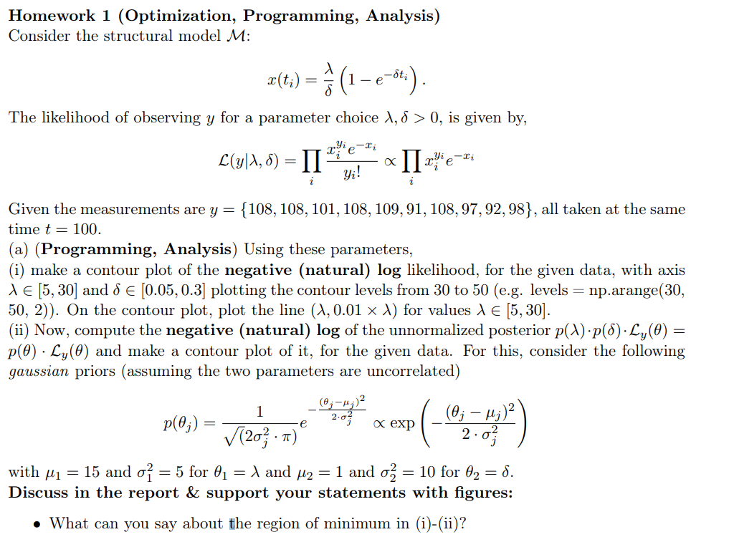

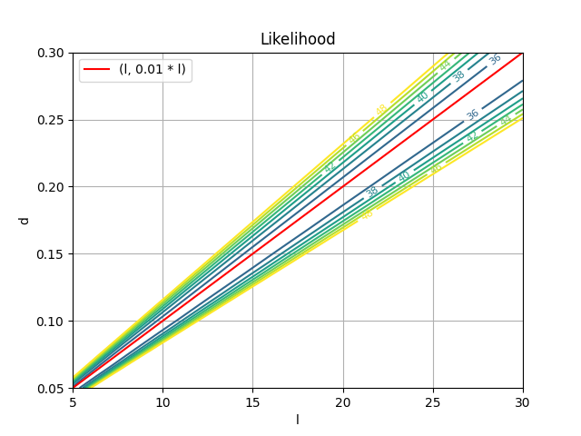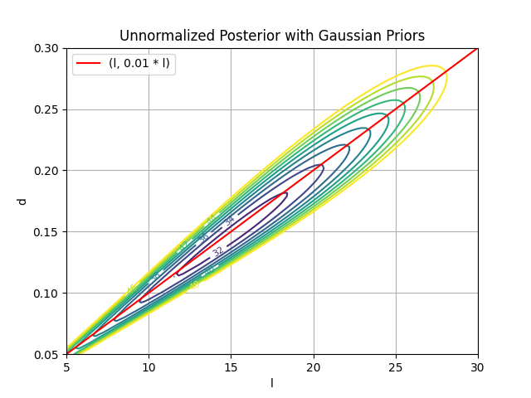

We can see that the region of minimum is along the (λ,0.01\*λ) line, however in posterior the region does not extend infinitely long along the line like in likelihood, but is rather confined to a region near the initial parameter. This is easy to interpret as posterior is calculated as a product of likelihood and priors, where priors were Gaussian and thus should be concentrated around the initial parameter, or the mean of the Gaussian distribution.

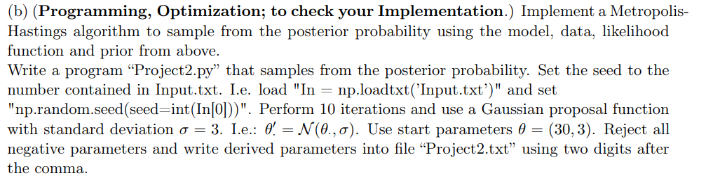

Please refer to the file “Project2.py” in attachment.

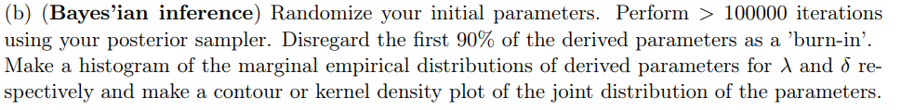

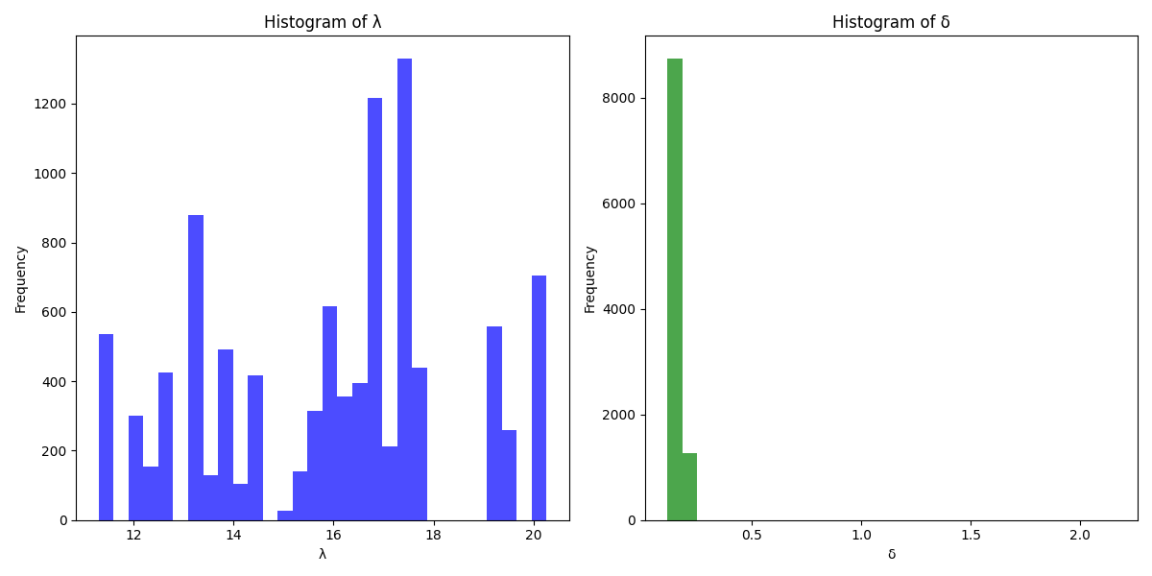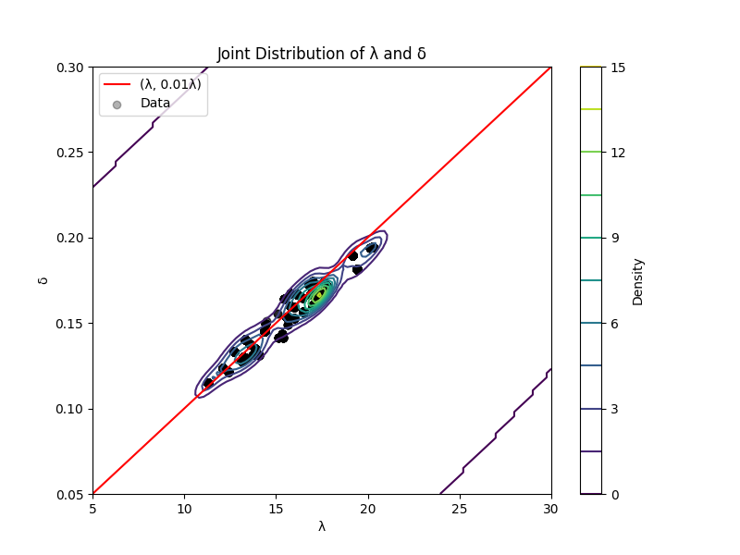

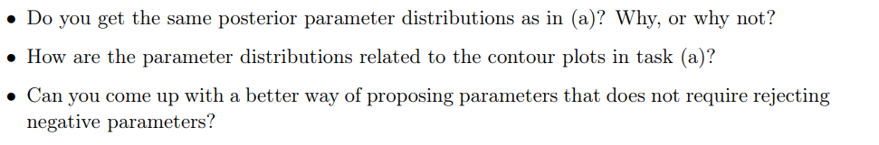

1. Parameters are centered around few clusters, because parameters close to the previous estimate are more likely to be chosen in the next round of estimation. Also, the distribution has no tails, because after the burn-in phase, we have already arrived in the region of minimum and it is very unlikely for the algorithm to explore outside the ‘valley.’ Also, the parameters are centered around few clusters, as it is more likely for a parameter to be chosen if it is nearer to the previous estimate of the algorithm.
2. The contour plot appears to be similar to the one from task (a), but with some differences. No parameters are to be found outside this small region of minimum, because we have ‘burnt in’ the first 90% of the estimated parameters and after that, we should be already inside this region of minimum, as discussed earlier.
3. We could use a distribution that has no negative parameters. Rejecting negative parameters could give us some ‘satisfactory’ results, but this has some faults as then, it is not really a real probability distribution. We could resolve the issue by using log-normal distribution, but this also has a small problem of being not symmetrical. As symmetry implies negative values in continuous distributions, we would have to make a ‘cut-off’ distribution, where it is only defined as a non-zero value for a range of values and 0 otherwise. To set up such a cut-off, we will have to examine the model and also run some exploratory tests.